EXPERIMENT : 04

NAME : KIRUTHICK.SM ROLL NO : 240701263

Experiment Title
Design and Implementation of a Login Page Interface
Objective 🎯
To design a simple and user-friendly login page that allows users to enter their email and password in order to access the system securely.
Materials / Tools Used 🛠️
- HTML – To create the structure of the login form
- CSS – To design the layout, colors, and alignment
- Input fields – For email and password entry
- Button element – For submitting login details
Procedure
1. Creating the Login Container
A rectangular login panel is placed at the center of the page.
- The background color of the container is dark teal/blue to create contrast.
- The outer page background is green, giving the interface a fresh and modern look.
2. Adding the Login Title
At the top of the form, a heading “LOGIN” is displayed in yellow color.
This helps users quickly understand the purpose of the page.
3. Creating the Email Input Field
An input box labeled Email is added.
- It allows the user to enter their registered email address.
- Placeholder text “Enter your email” guides the user on what to type.
4. Creating the Password Input Field
Another input box labeled Password is created.
- Users enter their account password here.
- The placeholder text “Enter your password” helps guide the user.
5. Adding the Sign-In Button
A red “Sign In” button is placed below the input fields.
Function:
- When clicked, it submits the login information for verification.
Result ✅
A clean and functional login page interface is successfully created where users can:

- Enter their email address
- Enter their password
- Click the Sign In button to access their account

Conclusion 📌
This experiment demonstrates how HTML and CSS can be used to design a secure and visually appealing login form, which serves as the entry point for users to access a website or application.

LINK:
https://www.figma.com/design/YEH2VH8E6S4vyaO5ZqU9Yw/Untitled?node-id=0-1&p=f&t=bJDIzdYl7mbGFcND-0
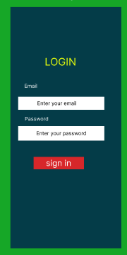
k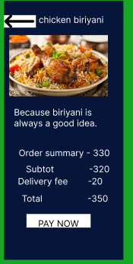
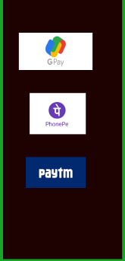
kkk